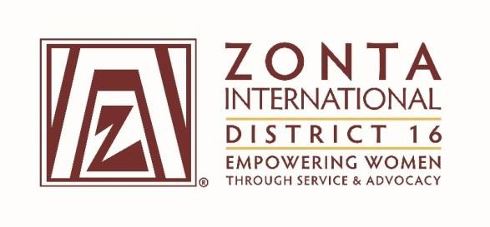

“Toolkit”
Violence against Women is a Workplace Issue

This toolkit has been prepared for Clubs to use as part of the Zonta says No to Violence against Women campaign and to further align our advocacy work to the Women’s Empowerment Principles.
The toolkit is based on the themes raised in the paper, Productivity gains from Workplace Protection of Victims of Domestic Violence. It is intended to be used as a resource for Clubs for presentations to employers, panel discussions, debates or at club meetings. Suzanne Snively one of the co-authors of the paper is happy to be involved in promoting this work.
All documents I have referenced are included in the toolkit so Clubs can access more information or source more material as they choose. I have included a PowerPoint presentation that Clubs are welcome to use – this can be adjusted to suit different presenters or contexts.

Christine Cook, Advocacy Chair, Zonta District 16, 2015.

The Women’s Empowerment Principles
- Establish high-level corporate leadership for gender equality
- Treat all women and men fairly at work—respect and support human rights and non-discrimination
- Ensure the health, safety and well-being of all women and men workers
- Promote education, training and professional development for women
- Implement enterprise development, supply chain and marketing practices that empower women
- Promote equality through community initiatives and advocacy
- Measure and publicly report on progress to achieve gender equality

http://weprinciples.org

Contents of the Toolkit

Document Summary
PowerPoint Presentation. Violence against Women is a Workplace Issue.

Related Documents
Domestic Violence – Victims’ Protection Bill. Consultation Document (Jan Logie)
Domestic Violence Workplace Rights and Entitlements Project “Safe at Home, Safe at Work. National Domestic Violence and the Workplace Survey, 2011. (Ludo Mc Ferran, Australian Domestic and Family Violence Clearinghouse, Centre for Gender Related Violence Studies)
Diversity delivers a distinct competitive advantage. Bank of New Zealand, Diversity Case Study, 2014.
Productivity gains from Workplace Protection of Victims of Domestic Violence. (Kahui, Ku and Snively, 2014)
Supporting Staff Affected by Family Violence. Ministry of Social Development. (Kerry Tudor)
The Audacity of Caring. Context for Debate 21 July 2015. (Suzanne Snively)

